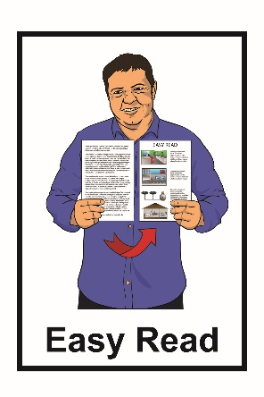

Land Safety Code

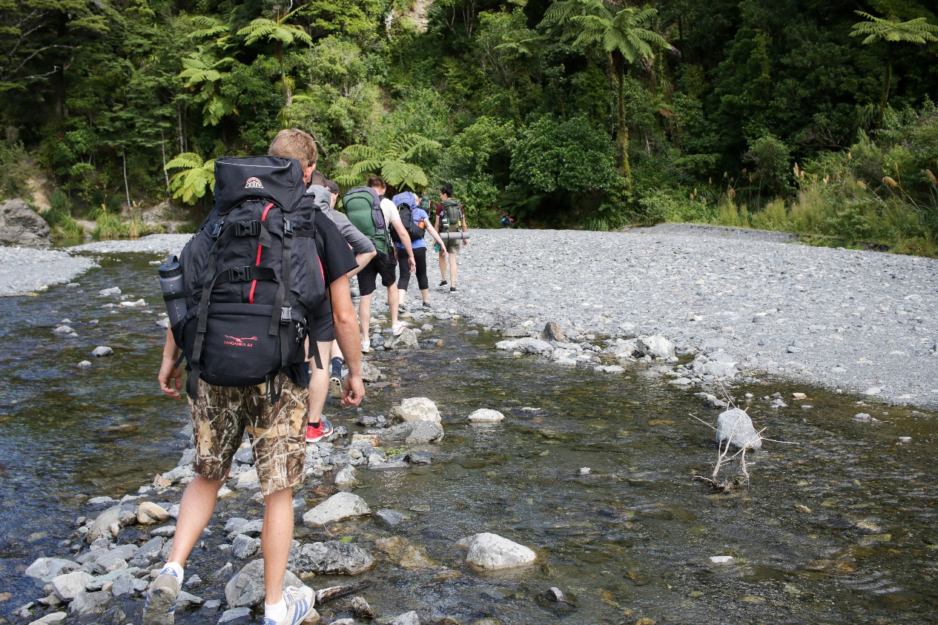

Things you can do to stay safe
while on your trip

Department of Conservation

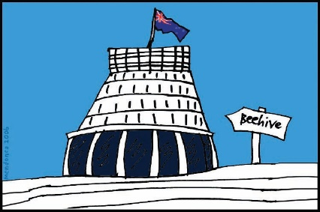

The Department of Conservation is a government agency in New Zealand.

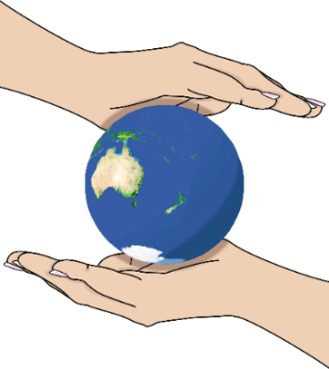
Conservation means protecting the natural world around us.

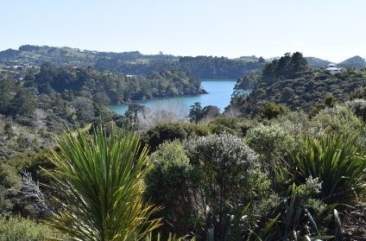
The Department of Conservation is in charge of protecting our:

- natural land

- important places.

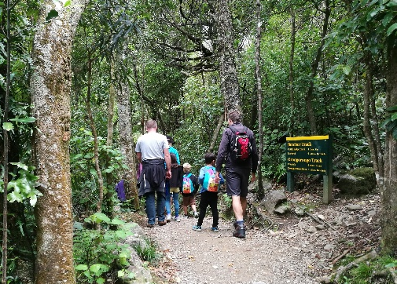
This Easy Read document is about the Land Safety Code.

Be prepared

Stay safe while on your trip by following the Land Safety Code.

The Land Safety Code is made up of 5 important rules to help you stay safe while on your trip.

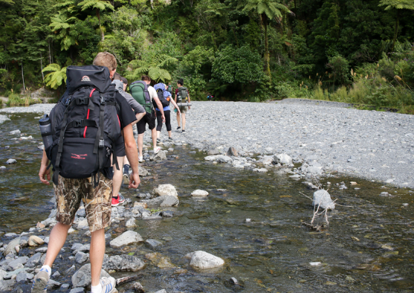
- Choose a day trip or overnight trip that is right for you.

You should:

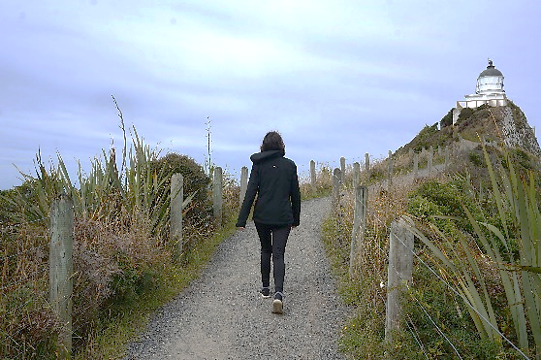
- learn about the place you are planning to visit

- make sure you have the skills to do the trip such as being able to walk a long way or up hills.
- Check that the weather is good for your trip

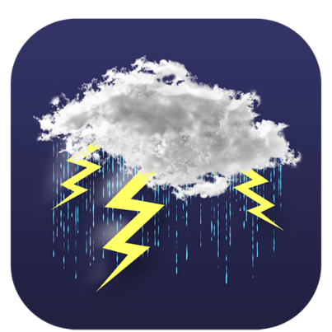
The weather can change fast.

You may need to change if your plans if the weather is not good for your trip.

- Pack a bag to take on your trip.

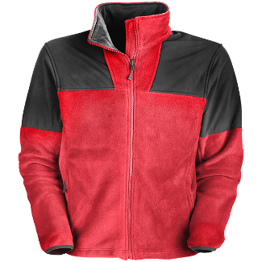
The bag should have things like:

- warm clothes
- extra food

- water.

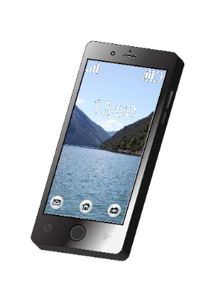
- Tell your family or friends about the trip you have planned.
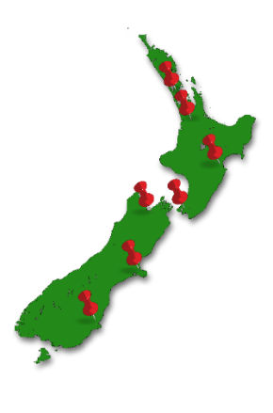

It is a good idea tell them:

- where you are going

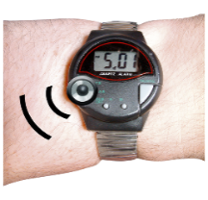
- who you are going with

- what time you plan to get back from your trip
- to ring 111 if you do not come back from your trip.

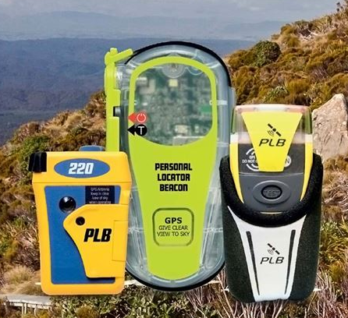
You may want to take a distress beacon.

A distress beacon is an electronic device that you can use to help rescue workers find you if you are lost or hurt.
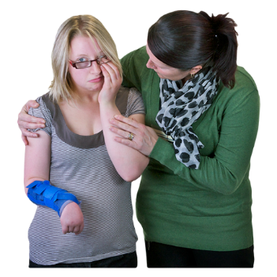
- Take care of:

- yourself

- each other.

This means that while you are on your trip you should:

- eat food

- drink water

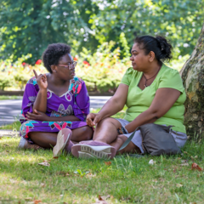
- take breaks to rest

- stay with your group

- make decisions together.

Where to find more information

You can find more information about the Department of Conservation on their website:

https://www.doc.govt.nz/

You can also:

Email: enquiries@doc.govt.nz

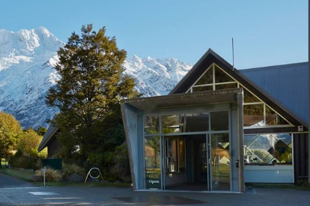
You can find a list of all the Department of Conservation visitor centres around New Zealand at this website:
https://www.doc.govt.nz/footer-links/contact-us/visitor-centres/
This information has been provided by the Department of Conservation.

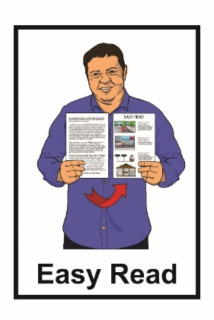
It has been translated into Easy Read by the Make It Easy service of People First New Zealand Inc. Ngā Tāngata Tuatahi.

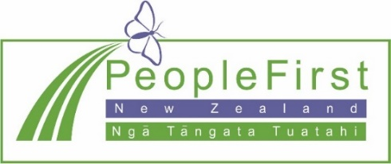
The ideas in this document are not the ideas of People First New Zealand Inc. Ngā Tāngata Tuatahi.

Make It Easy uses images from:
- Changepeople.org

- Photosymbols.com

- Sam Corliss.

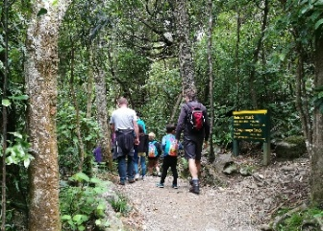
Thank you to Benhi Dixon for permission to use the image of a family walking the Orongrongo track.

Other images provided by Department of Conservation.

All images used in this Easy Read document are subject to copyright rules and cannot be used without permission.

Published August 2021.

